***NAME : Himanshu Dixit***

***ENROLL NO. : 21103262***

***BATCH : B10***

***Software Development fundamentals-2 [EVEN 2022]***

***Tutorial Sheet -3 (Week 3)***

***Q1.*** *Define a class to represent a book in a library. Include the following members:*

*Data Members Book Number, Book Name, Author, Publisher, Price, No. of copies issued, No. of copies Member Functions:*

***(i)*** *To assign initial values*

***(ii)*** *To issue a book after checking for its availability*

***(iii)*** *To return a book*

***(iv)*** *To display book information.*

***Solution :***

#include <iostream>

using namespace std;

class library

{

int Book_Number;

string Book_Name, Author, Publisher;

float Price;

int No_of_copies_issued, No_of_copies;

public:

library()

{

Book_Number=0;

Book_Name="Null";

Author="Null";

Publisher="Null";

Price=0.0;

No_of_copies=0;

No_of_copies_issued=0;

}

void enterdetails()

{

cout<<"Enter the Book Number : ";

cin>>Book_Number;

cin.ignore();

cout<<"Enter the Book Name : ";

getline(cin,Book_Name);

cout<<"Enter the Book Author : ";

getline(cin,Author);

cout<<"Enter the Publisher Name : ";

getline(cin,Publisher);

cout<<"Enter the Number of copies of book : ";

cin>>No_of_copies;

}

void issue(int n)

{

No_of_copies_issued=n;

if(No_of_copies_issued<=No_of_copies)

{

cout<<"\nBook is issued";

No_of_copies=No_of_copies-No_of_copies_issued;

}

else

cout<<"\nBook is not available";

}

void returned(int n)

{

No_of_copies=n+No_of_copies;

cout<<"\nBook is returned successfully";

}

void showdetails()

{

cout<<"\nBook Number : "<<Book_Number;

cout<<"\nBook Name : "<<Book_Name;

cout<<"\nBook Author : "<<Author;

cout<<"\nPublisher Name : "<<Publisher;

cout<<"\nNumber of copies of book : "<<No_of_copies;

}

};

int main()

{

library l;

int n1,n2;

l.enterdetails();

cout<<"Enter the number of copies u wants to issued : ";

cin>>n1;

l.issue(n1);

l.showdetails();

cout<<"\nEnter the number of copies u wants to submit : ";

cin>>n2;

l.returned(n2);

l.showdetails();

return 0;

}

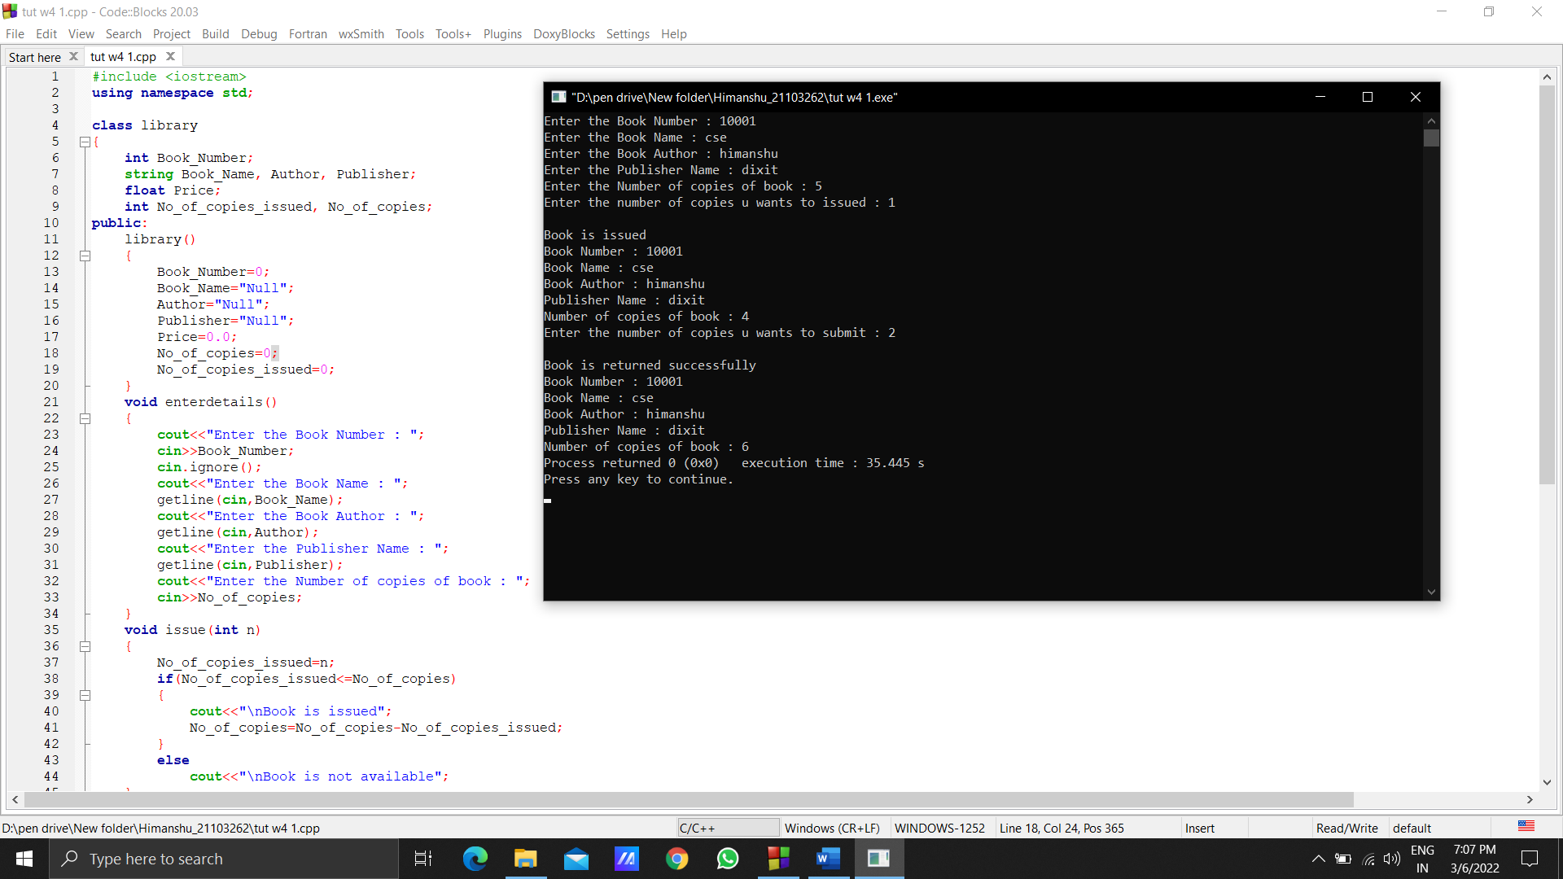

***Q2.*** *Declare a class to represent bank account of 10 customers with the following data members. Name of the depositor, Account number, Type of account (S for Savings and C for Current), Balance amount.*

*The class also contains member functions to do the following:*

***(i)*** *To initialize data members*

***(ii)*** *To deposit money*

***(iii)*** *To withdraw money after checking the balance (minimum balance in Rs.*

*1000)*

***(iv)*** *To display the data members*

***Solution :***

#include <iostream>

using namespace std;

class customer

{

char Name[20];

int Acc_Num;

char type_account;

float Balance;

public:

customer()

{

Name[20]='N';

Acc_Num=0;

type_account='D';

Balance=0.0;

}

void enterdetails()

{

cout<<"Enter Name of customer : ";

cin>>Name;

cout<<"Enter Account Number of customer : ";

cin>>Acc_Num;

cout<<"Enter Account type of customer : ";

cin>>type_account;

cout<<"Enter Balance of customer : ";

cin>>Balance;

}

void deposit()

{

float m;

cout<<"\nEnter the money u wants to deposit : ";

cin>>m;

Balance=Balance+m;

cout<<"money is deposited";

}

void withdraw()

{

float m;

cout<<"\nEnter the money you wants to withdraw : ";

cin>>m;

Balance=Balance-m;

if(Balance>=1000)

cout<<"\nMoney is successfully withdraw.";

else

{

Balance=Balance+m;

cout<<"\nMoney is not able to withdraw.";

}

}

void display()

{

cout<<"\nName of customer : "<<Name;

cout<<"\nAccount Number of customer : "<<Acc_Num;

cout<<"\nAccount type of customer : "<<type_account;

cout<<"\nBalance of customer : "<<Balance;

}

};

int main()

{

customer c[10];

int n,m;

for(int i=0; i<10; i++)

{

cout<<"\nENTER CUSTOMER "<<i+1<<" Details : \n";

c[i].enterdetails();

}

cout<<"\nEnter the index of the customer who wants to deposit money : ";

cin>>n;

c[n].deposit();

cout<<"\nEnter the index of the customer who wants to withdraw money : ";

cin>>m;

c[m].withdraw();

for(int i=0; i<10; i++)

{

cout<<"\nCUSTOMER "<<i+1<<" Details : \n";

c[i].display();

}

return 0;

}

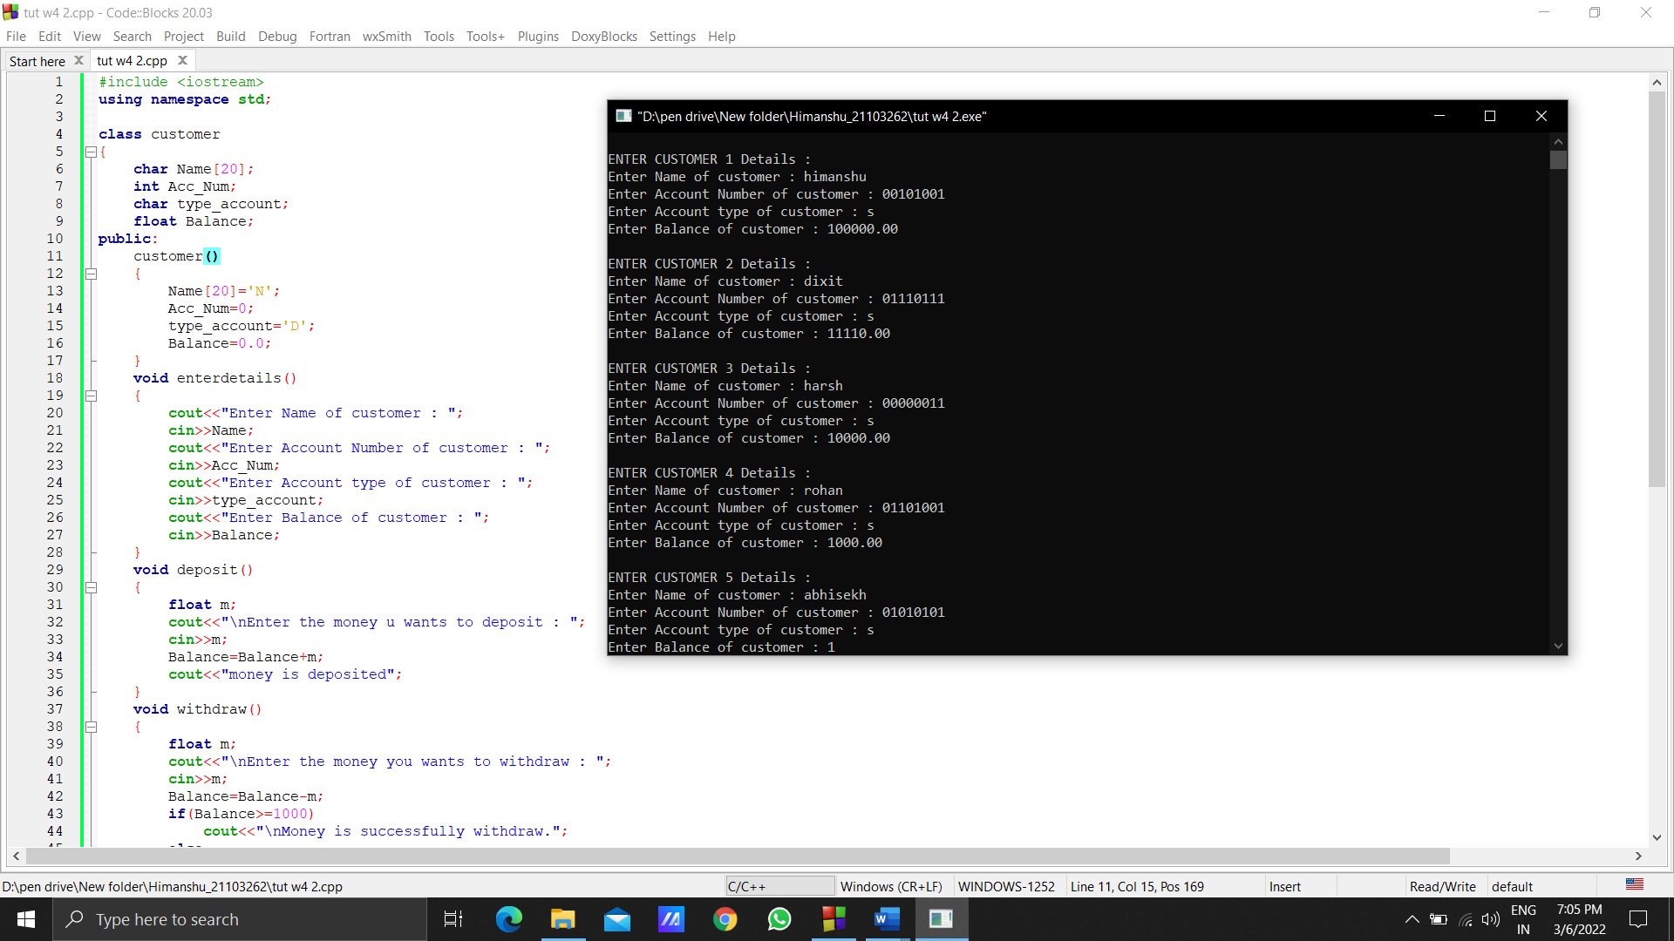

***Q3.*** *What are static members of a class? When and how are they useful?*

***Solution :***

Static members of a class is in which these have to store memory once in a program . Only one copy of that member is created for the entire class and is shared by all the objects of that class, no matter how many objects are created.

***Q4.*** *Consider the following class declaration and answer the questions below:*

*class SmallObj*

*{*

*private:*

*int some,more;*

*void err_1() {cout<<"error";}*

*public:*

*void Xdata(int d) {some=d;more=d++; }*

*void Ydata() {cout<<some<<" "<<more; }*

*};*

***(i)*** *Write the name that specifies the above class.*

***(ii)*** *Write the data of the class with their access scope.*

***(iii)*** *Write all member functions of the class along with their access scope.*

***(iv)*** *Indicate the member function of the SmallObj that sets data.*

***Solution :***

*(i) SmallObj*

*(ii) data members : some,more*

*(iii) member function : void Xdata(int d),void Ydata(),void err_1*

*(iv) void Xdata(int d)*